**Digital Communication**

**Lab Manual 7**

**Objective:**

Our objective is to compare performance based theoretical and simulated BER digital modulation techniques (BPSK, QPSK and QAM) over AWGN and Rayleigh Channel.

**Introduction:**

Digital modulation schemes provide more information carrying capacity, better quality communication, data security and RF spectrum sharing to accommodate more services. So we have to analyze the parameters, component, and structures of the channels. In this lab we will implement different digital modulation techniques and compare their BER vs Eb/No curves to see which technique performs better.

Here Eb/N0 (the energy per bit to noise power spectral density ratio) is an important parameter used in digital communication or data transmission. It is a normalized signal-to-noise ratio (SNR) measure, also known as the "SNR per bit". We use it for comparing the bit error rate (BER) performance of different digital modulation schemes.

**Modulation and Demodulation:**

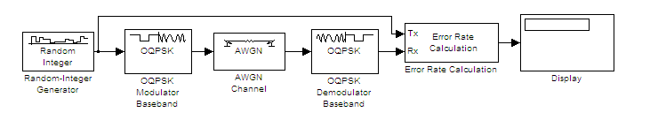

**BPSK :**

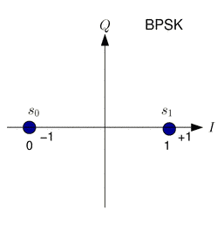

**QPSK:**

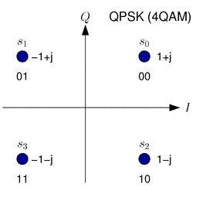

**Methodology:**

%%%%%%%%%%%%%%%%%%%%%%%%%%%%%%%%%%%%%%%%%%%%%%%%%%%%%%%%%%%%%%%%%%%%%%%%%%%

% This program is used to calculate the Bit Error Rate (BER) of QPSK in an

% Additive White Gaussian Noise (AWGN) channel. The modulation and

% demodulation is done at baseband. Complex numbers are used to model the

% in-phase and quadrature components of a QPSK signal. The length of the

% symbol sequence and range of EbNo can be varied.

%

% By Yasir Ahmed

% www.raymaps.com

%%%%%%%%%%%%%%%%%%%%%%%%%%%%%%%%%%%%%%%%%%%%%%%%%%%%%%%%%%%%%%%%%%%%%%%%%%%

clear all; %Clear all variables

close all; %Close all figures

l=1e6;

EbNodB=0:2:10;

EbNo=10.^(EbNodB/10);

for n=1:length(EbNodB)

si=2*(round(rand(1,l))-0.5); %In-phase symbol generation

sq=2*(round(rand(1,l))-0.5); %Quadrature symbol generation

s=si+j*sq; %Adding the two parallel symbol streams

w=(1/sqrt(2*EbNo(n)))*(randn(1,l)+j*randn(1,l)); %Random noise generation

r=s+w; %Received signal

si_=sign(real(r)); %In-phase demodulation

sq_=sign(imag(r)); %Quadrature demodulation

ber1=(l-sum(si==si_))/l; %In-phase BER calculation

ber2=(l-sum(sq==sq_))/l; %Quadrature BER calculation

ber(n)=mean([ber1 ber2]); %Overall BER

end

semilogy(EbNodB, ber,'o-') %Plot the BER

xlabel('EbNo(dB)') %Label for x-axis

ylabel('BER') %Label for y-axis

grid on %Turning the grid on

**AWGN and Rayleigh Channel:**

Eb_No_dB = [0:20]; % multiple Eb/N0 values

for i = 1:length(Eb_No_dB)

sig = sqrt(1/10^(Eb_No_dB(i)/10)); % noise variance

n = sig*(randn(2,N) + 1i*randn(2,N)); % Additive white gaussian noise prototype

h = randn(2,N) + 1i*randn(2,N); % Rayleigh channel

y = h.*Data + n; % bit-streams corrupted by Rayleigh channel & AWGN

y_rcv = y./h; % equalization of received data by channel information at the receiver

Data_rcv = [Refresh(real(y_rcv(1,:))); Refresh(real(y_rcv(2,:)))]; % Regenerating the received bits by threshold comparison

Err(i) = sum(sum(round(Data) ~= round(Data_rcv))); % computing the bit error in each simulation

end

**TASK:**

Show Bit Error rate Curve for BPSK, QPSK and 8PSK modulation on AWGN and Rayleigh Channel using Matlab .

it can be said that for M-ary modulation, if the value of M increases the performance of the system will be degrade. You have to show the change in performance w.r.t the Modulation technique and factor M.

Your output should show the BER curves for all techniques as shown in Fig. for BPSK,8-PSK and 16 PSK over AWGN Channel.

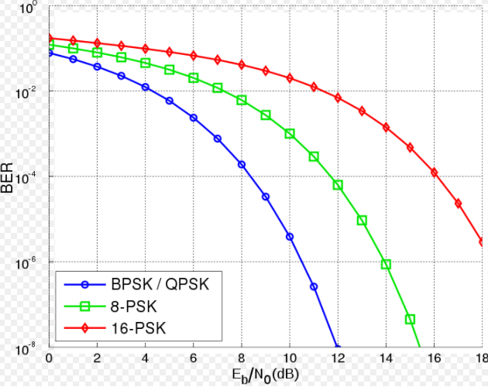

**Note:**The theoretical BER (given SNR per bit ration – Eb/N0) for various linear modulations. Note that the Eb/N0 values used in that table are in linear scale [to convert Eb/N0 in dB to linear scale – use Eb/N0(linear) = 10^(Eb/N0(dB)/10) ]. A small script written in Matlab (given below) gives the following output.